Your Septic System: Considerations for Shoreline Property Owners

If you live on shoreline property, maintaining your septic system requires more care than maintaining a similar system located elsewhere. Soil and water conditions near the shoreline, including thin or rocky soils, clay soils, and high water tables, may make a traditional septic system less efficient at treating waste. Remember that most wastewater treatment happens in the soil of the absorption area. Septic systems on shoreline property are often close to both groundwater and surface waters, and drainfields are sometimes saturated during high water periods, such that partially treated wastewater is likely to enter adjacent lakes and streams. Also, as shorelines erode, the distance between the septic system and the shoreline decreases.

Water pollution can occur even though your system appears to be working well and complies with local health department codes. The system must be customized to the specific site and may need to employ more advanced treatment technology.

The Effects of Septic System Wastes on Lakes and Streams

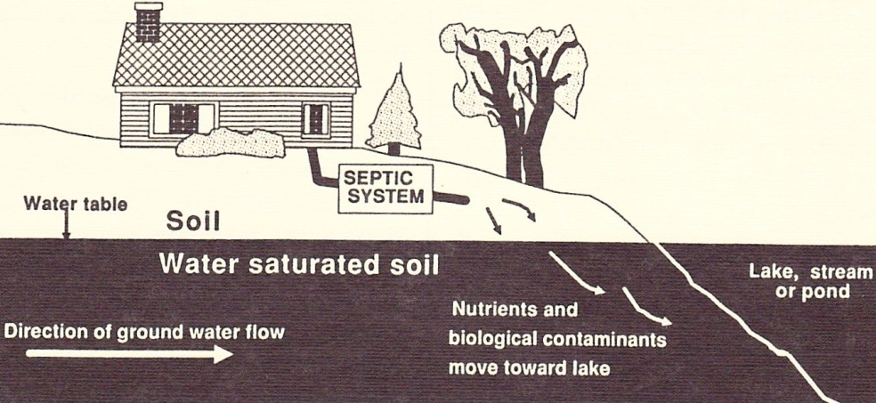
Nutrients (especially phosphorus) from inadequate septic systems play a major role in causing excessive weed and algae growth in lakes and ponds. Just a small amount of additional phosphorus in a lake or pond can increase the growth of algae and/or aquatic weeds. When overgrown algae and plants die rapidly and decompose, oxygen is removed from the water, which threatens fish and other aquatic animals. Excessive weed growth also makes boating, fishing and swimming less enjoyable.

Wastewater from your septic system that reaches adjacent surface waters also increases the chance that wildlife, swimmers, and downstream users are exposed to infectious bacteria and viruses that are associated with wastewater.

Signs That Contaminants are Reaching the Water
In addition to the symptoms of septic system failure described in the publication Septic System Failure, look for these symptoms to tell if waste from your system is reaching surface water:

Excessive weed or algae growth in the water near your shore. Other nutrient sources such as sediment and lawn fertilizer runoff or the resuspension of shallow sediments could also lead to this type of problem. Septic systems, however, are often prime suspects as sources of nutrients.

Unpleasant odors, soggy soil or sewage flow over the land surface. These symptoms often indicate failure and the need for drastic action such as replacement of the system. Under these conditions, wastewater could travel directly into nearby surface waters instead of being treated in the soil.

Water test results indicate the presence of biological contamination.
These tests may indicate the presence of harmful bacteria, viruses, or protozoa in the water. Although wastes from septic tanks are not the only source of these contaminants, they are likely suspects. Contact your local health department for more information on testing programs (see contact info on the back of the Your Septic System folder).

An increase in infections or illnesses associated with swimming in the area. These are most often minor ailments, such as ear or eye infections, but could be major diseases, such as dysentery or hepatitis.

Indicator dye put into your septic tank reaches lakes or ponds.
Special dyes may help to trace problems.

How to Prevent Problems
The basic maintenance for all septic systems (regular pumping and maintenance, water conservation, and protecting the drainfield) is even more important near surface waters. In addition to the tips described in other publications in this series, consider these measures:

Participate in a community sewage system, if available. Municipal sewer systems may not be accessible at a reasonable cost, but multiple-home “cluster” systems may be an option. Talk with your neighbors, lakeshore association, and health department about shared maintenance contracts and other possible community solutions. Before selecting a larger-scale, community-based solution, be sure that it will yield the anticipated results. Many factors contribute to excessive weed growth and other water quality effects.

Replace or upgrade your septic system. Although this alternative is costly, sometimes it is the only alternative, especially when your system is undersized because of conversion of a seasonal residence for year-round use. If you're building a new home, construct the septic system as far away from the shoreline as possible. Design the system to meet your present as well as future needs. If you are building a small summer home with plans to enlarge it for year-round use when you retire, design the system to accommodate that increased future use.

Install an “alternative” or “advanced” treatment system. A septic system is one type of on-site wastewater treatment system (OWTS). See the publication on Alternative and Advanced On-site Wastewater Treatment Systems for more information on these systems, which use modifications of traditional septic tanks or drainfields to improve treatment efficiency and protect groundwater. Installation of these systems requires close cooperation with your local health department, an experienced contractor, and the manufacturer. Some systems require electric power to operate.

Consider a waterless toilet. Incinerating or composting toilets greatly reduce the volume of wastewater that must be treated. Talk to your local health department about waste disposal options and permits.

Add appropriate plants between your drainfield and the shoreline. This involves planting areas of small shrubs and trees to help intercept and absorb some of the nutrients before they reach the shoreline. Roots may also stabilize the shoreline and reduce erosion that can contaminate the stream and expose the far end of the drainfield. Make sure roots will not damage the drainfield.

The original version of this publication was developed by Cornell Cooperative Extension (CCE) via a grant from the NYS Water Resources Institute with funds provided by the NY State Legislature through the Dept. of Agriculture and Markets. The project team included A. Meyer, M. Keith, J. Saumier, and M. Shortlidge of Dutchess, Putnam, Rockland, and Westchester Counties. It was adapted from a Michigan State University Cooperative Extension System bulletin by D. Solomon and E. Dersch. It was revised by A. Galford with input from county and NYS health departments and the CCE Water Resources PWT. This material is based upon work supported by Smith-Lever funds from the National Institute of Food and Agriculture, U.S. Department of Agriculture. Any opinions, findings, conclusions, or recommendations expressed in this publication are those of the authors and do not necessarily reflect the view of the U.S. Dept. of Agriculture. Printed 01/2013

