Alternative and Advanced On-site Wastewater Treatment Systems

Some properties lack the volume and type of soil needed for a conventional septic system composed of a septic tank and soil absorption drainfield. This is common in many regions of New York State. On shoreline properties, thin rocky soils, steep slopes, and small lot sizes combine to create a wastewater treatment challenge. The original septic system on a property may have reached the end of its design life or failed early without enough room for replacing it with the same type of system.

An on-site wastewater treatment system (OWTS) may be possible but require the use of multiple or modified tanks and/or modified absorption area technologies. These “alternative”, “advanced”, or “enhanced” systems have undergone much recent technological and regulatory change, reflected in changes in NYS Dept. of Health regulations in 2010 and the revised Residential OWTS Design Handbook in 2012. Consult your county or district health department for options on challenging sites (contact info on the back of the Your Septic System folder).

Some of the treatment principles employed in these systems and examples of techniques include:
- Increasing the surface area on which bacteria live
  - Use high surface area materials
  - Spread small volumes of wastewater across a wide area
- Increase the treatment time before wastewater is released to the absorption area
  - Distribute effluent gradually using timed doses
  - Recirculate wastewater through treatment components multiple times
- Promote the growth of aerobic (oxygen-using) bacteria in the system
  - Add oxygen to the storage tank by bubbling air into it
  - Add oxygen to the storage tank by physically mixing the tank contents
- Artificially create absorption areas with deeper and different soil
  - Pump effluent up to mounds or other artificially built systems

These systems can achieve remarkable effluent water quality but they present some challenges.
- Custom engineering, installation, and permitting.
- Some components require electricity for pumps, aeration, control panel, alarm system, etc.
- Service contracts for inspection, parts, and pumping are a good idea and often required for permitting.

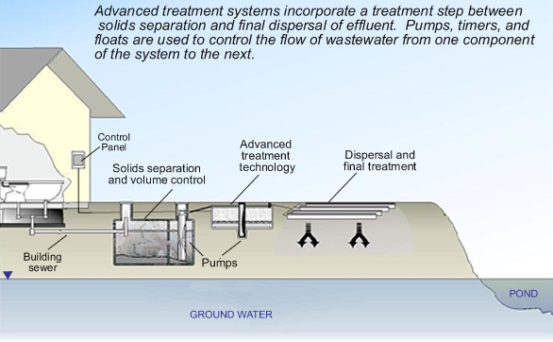

Figure courtesy of University of Rhode Island Onsite Wastewater Resource Center http://www.uri.edu/ce/wq/RESOURCES/wastewater/Onsite_Systems/Advanced/index.htm

Written by Amy Galford, Extension Associate, College of Human Ecology, Cornell University. This material is based upon work supported by Smith-Lever funds from the National Institute of Food and Agriculture, U.S. Department of Agriculture. Any opinions, findings, conclusions, or recommendations expressed in this publication are those of the authors and do not necessarily reflect the view of the U.S. Dept. of Agriculture. Printed 01/2013.

