Lab 4 – Assignment Question 1 Detailed Instructions
LAB DUE: Friday, October 12 (in-class hard copy or dropped off to 918 Bradfield Hall)
Based on the data we collected over the four days, plot an infiltration curve and determine the saturated infiltration rate for the Perc test (exercise A), the three turf plots at the research farm (exercise B) and the four turf plots as the golf course (exercise C). Use all four days of data to determine the average rates over the four days. Display the curves that you produce in addition to the determined saturated infiltration rate.
Hints:
- Calculate infiltration rate in cm/hr using the spreadsheet posted. Use the change in water height over the time interval to calculate infiltration rate in cm/min then multiply times 60 for cm/hr.
- Exclude last timepoints due to rapid infiltration from suction effect
- Make a combined graph for all days, groups, and runs for each treatment (sand, silt loam, green, fairway, etc). The easiest way (in Angela’s opinion) to do this is create a blank scatter plot, right click on the plot and select “Select Data” then add separate data series for each run (see Figure 1 below). Name each data series with the day, group number, and run; for example Monday G1_1. There will be many data series for some (e.g. the “sand” turf plot) and only 2 or 3 for some - that’s ok!
- Be sure to include an x and y axis label with units.
- In total you should have the following plots:
Perc test
Sand (research farm)
Silt loam (research farm)
Clay (research farm)
Green (golf course)
Collar/edge (golf course)
Rough (golf course)
Fairway (golf course)
- Estimate the saturated infiltration rate by finding the point where the data levels off and tracing a straight line to the corresponding point on the x-axis (about 32 cm/hr in the example below) (Figure 1).
SILT LOAM
- Be sure to also answer the short-answer questions in the lab assignment (Qs 2 and 3).

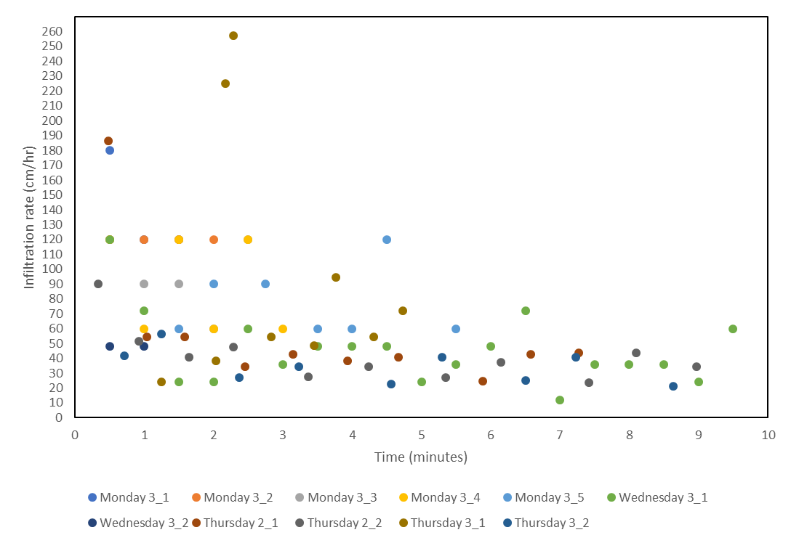
SILT LOAM
Figure 1. Example infiltration plot for silt loam research plot. Dotted line and red circle indicate the saturated infiltration (conductivity) rate (Ksat).

