Lab 4 Detailed Plotting Instructions
1. Type formula into box and press Enter. For infiltration rate, find the change in height over the time interval.
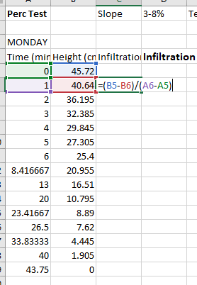
2. Drag the formula down the column. Leave the last cell blank.

3. For the infiltration rate in cm/hr, multiple time 60. Drag down to fill column.
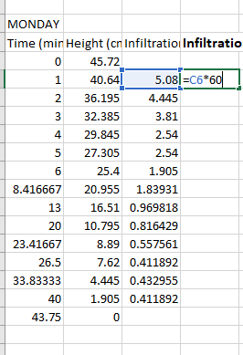
4. Repeat for every infiltration run for all groups and treatments. For the perc test, should look like this:
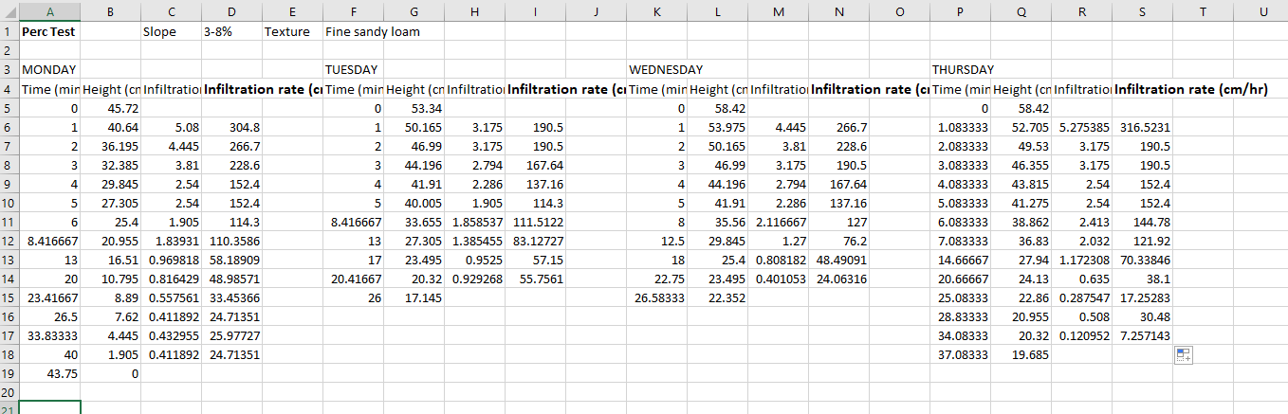
6. Make sure an empty cell is selected. Go to Insert – Charts – Scatter. It will be blank.
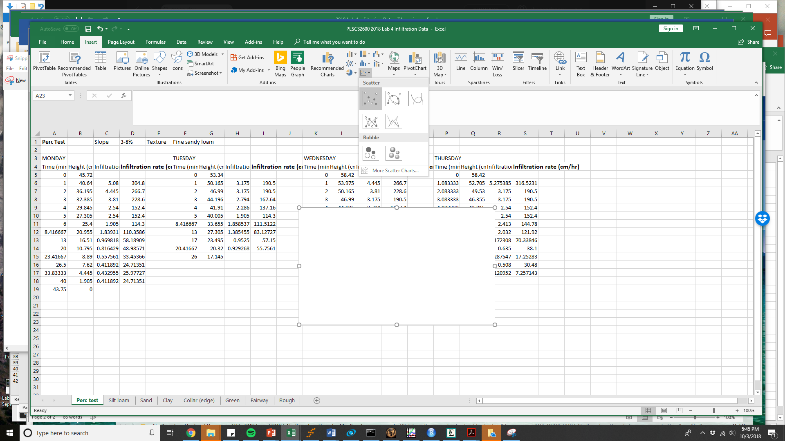
7. Move the chart so it doesn’t overlap the data.
8. Right click on the blank chart and select “Select Data”. A box will pop up for the data selection.
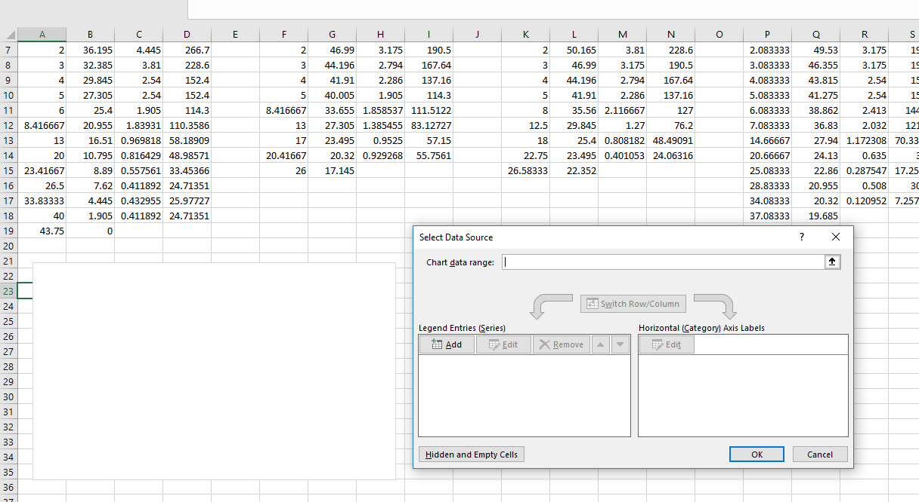
9. To add data series, click on Add. Type in the Series name (Monday, Tuesday, etc.)
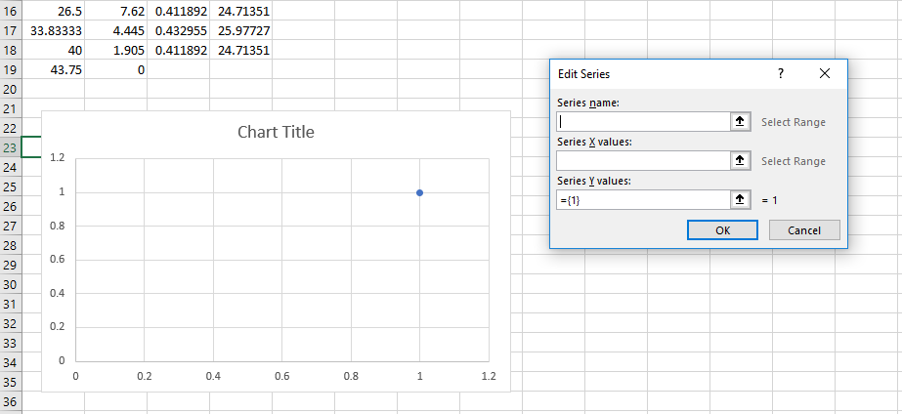
10. Select the values for X and Y. X will be the Time column and Y the infiltration rate (in cm/hr), then click OK.
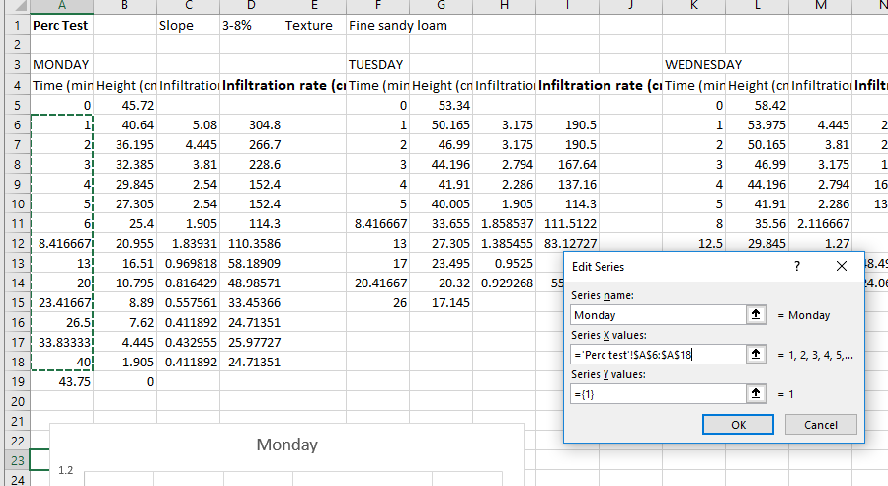
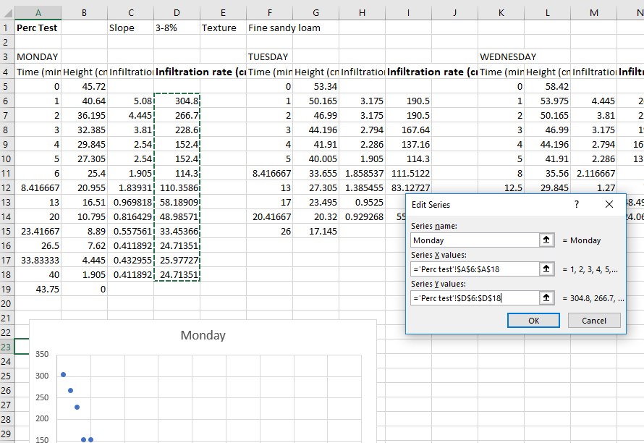

11. Click on Add again for each additional data series. In this example you will have 4 – Monday, Tuesday, Wednesday, and Thursday. For some of the treatments (e.g. sand) there will be many more because you have multiple groups per day and multiple runs per group.
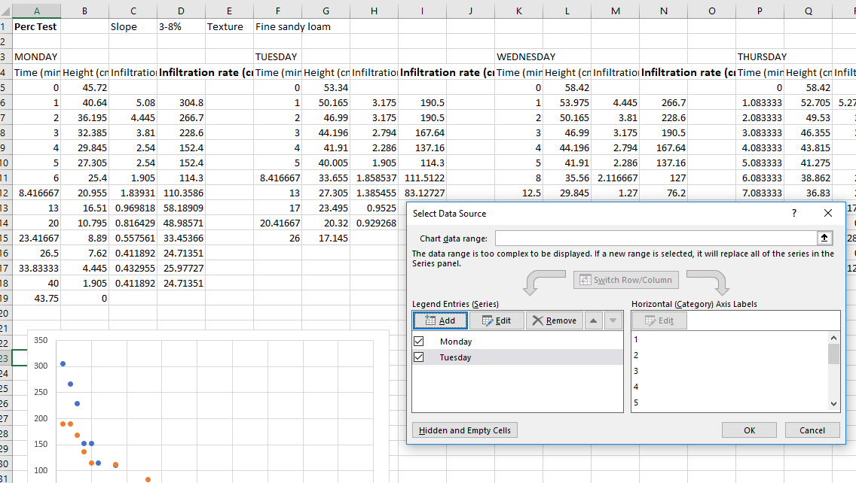

12. To add axis labels, click Add Chart Element > Axis Titles.

13. To change the number of gradations on the X-axis, right-click on the axis and select Format Axis. Change Major Units to 10.
14. To draw a horizontal line through the stable infiltration rate, select Insert > Shape and draw a line.

